

Department of Computer Science and Engineering
WEB TECHNOLOGY LABORATORY
LABORATORY MANUAL
SUBCODE: BCSL504, V SEMESTER B.E
PREPARED BY:
Mrs. Latheswari G
Assistant Professor




BANGALORE TECHNOLOGICAL INSTITUTE

(An ISO 9001:2015 Certified Institution)
Kodathi Village,VarthoorHobli, Bangalore East Tq, Bangalore Urban District, Bangalore-560035, Karnataka



COMPUTER SCIENCE AND ENGINEERING

VISION
To impart the best in academia that empowers the students of Computer Science and Engineering to contribute their best for the society.

MISSION
To mold the students as responsible computing professionals and citizens by providing an excellent soft skill learning environment
To equip the students with wisdom- theory and practical in the discipline of computing and the ability to apply knowledge to the benefits of the society
To Inculcate Technical Capabilities, Ethical values, & Leadership abilities for meeting the current and future demands of Industry and Society.
PROGRAM EDUCATIONAL OBJECTIVES (PEOs)
- Graduates will have strong foundation in fundamentals to solve Engineering problems in different domains.
- Graduates will have successful careers as computer Science Engineers and be able to lead & manage teams and contribute to the society.
- Graduates will instill interpersonal skills and attitudes in the process of Lifelong learning.
Program Specific Outcomes (PSO)
At the end of the program, the CSE graduates will be able to :

- Design and develop dynamic, interactive, and responsive websites using HTML, CSS, JavaScript, and modern front-end frameworks like React or Angula.
Develop server-side applications using technologies like Node.js, PHP, or Python, and integrate them with databases (SQL/NoSQL) for data storage and manage
WEB TECHNOLOGY LABORATORY
SEMESTER –V
Course Code |  | BCSL504 | CIE Marks | 50
Number of Contact Hours/Week |  | 0:0:2 | SEE Marks | 50
Total Number of Lab Contact Hours |  | 28 | Exam Hours | 03
Credits – 1
Course Learning Objectives:
- Learn HTML 5 elements and their use.
- Use of CSS for enhanced user interface presentation.
- Gain knowledge of JavaScript, AJAX and JQuery for dynamic presentation.
- Use of PHP to build Web applications.
- Design and develop Websites and Web applications
Descriptions (if any):
- Implement all the programs in “HTML” Programming Language and VSCODE.
Programs List:
1. | Develop the HTML page named as “Myfirstwebpage.html”. Add the following tags with relevant content.  - Set the title of the page as “My First Web Page”  - Within the body use the following tags:  - Moving text = “Basic HTML Tags”  - Different heading tags (h1 to h6)  - Paragraph  - Horizontal line  - Line Break  - Block Quote  - Pre tag  - Different Logical Style .
2. | Develop the HTML page named as “Table.html” to display your class time table.  a) Provide the title as Time Table with table header and table footer, row-span and col- span etc. b) Provide various colour options to the cells (Highlight the lab hours and elective hours with different colours.)  c) Provide colour options for rows.
3. | Develop an external style sheet named as “style.css” and provide different styles for h2, h3, hr, p, div, span, time, img & a tags. Apply different CSS selectors for tags and demonstrate the significance of each.

4. | Develop HTML page named as “registration.html” having variety of HTML input elements with background colors, table for alignment & provide font colors & size using CSS styles
5. | Develop HTML page named as “newpaper.html” having variety of HTML semantic elements with background colors, text-colors & size for figure, table, aside, section, article, header, footer… etc.
6. | Apply HTML, CSS and JavaScript to design a simple calculator to perform the following operations: sum, product, difference, remainder, quotient, power, square-root and square.
7. | Develop JavaScript program (with HTML/CSS) for: a) Converting JSON text to JavaScript Object b) Convert JSON results into a date c) Converting From JSON To CSV and CSV to JSON d) Create hash from string using crypto.createHash() method
8. | Develop a PHP program (with HTML/CSS) to keep track of the number of visitors visiting the web page and to display this count of visitors, with relevant headings. b. Develop a PHP program (with HTML/CSS) to sort the student records which are stored in the database using selection sort.
9. | Develop jQuery script (with HTML/CSS) for:  - Appends the content at the end of the existing paragraph and list.  - Change the state of the element with CSS style using animate() method  - Change the color of any div that is animated.
10. | Develop a JavaScript program with Ajax (with HTML/CSS) for:  - Use ajax() method (without Jquery) to add the text content from the text file by sending ajax request.  - Use ajax() method (with Jquery) to add the text content from the text file by sending ajax request.  - Illustrate the use of getJSON() method in jQuery d. Illustrate the use of parseJSON() method to display JSON values.

Laboratory Outcomes: The student should be able to:
- Design the experiment for the given problem using HTML, Javascript and CSS.
- Develop the solution for the given real-world problem using jQuery, Ajax and PHP.
- Analyze the results and produce substantial written documentation.
Conduct of Practical Examination:
- Experiment distribution
  - For laboratories having only one part: Students are allowed to pick one experiment from the lot with equal opportunity.
  - For laboratories having PART A and PART B: Students are allowed to pick one experiment from PART A and one experiment from PART B, with equal opportunity.
- Change of experiment is allowed only once and marks allotted for procedure to be made zero of the changed part only.
- Marks Distribution (Need to change in accordance with university regulations)
- For laboratories having only one part – Procedure + Execution + Viva-Voce: 15+70+15 = 100 Marks
- For laboratories having PART A and PART B
  - Part A – Procedure + Execution + Viva = 6 + 28 + 6 = 40 Marks
  - Part B – Procedure + Execution + Viva = 9 + 42 + 9 = 60 Marks

INDEX

SL.  NO. | PRACTICALS | PAGE NO.
1. | Develop the HTML page named as “Myfirstwebpage.html”. Add the following tags with relevant content.  - Set the title of the page as “My First Web Page”  - Within the body use the following tags:  - Moving text = “Basic HTML Tags”  - Different heading tags (h1 to h6)  - Paragraph  - Horizontal line  - Line Break  - Block Quote  - Pre tag  - Different Logical Style | 1-3
2. | Develop the HTML page named as “Table.html” to display your class time table.  - Provide the title as Time Table with table header and table footer, row-span and col-span etc.  - Provide various colour options to the cells (Highlight the lab hours and elective hours with different colours.)  - Provide colour options for rows. | 4-5
3. | Develop an external style sheet named as “style.css” and provide different styles for h2, h3, hr, p, div, span, time, img & a tags. Apply different CSS selectors for tags and demonstrate the significance of  each. | 6-7
4. | Develop HTML page named as “registration.html” having variety of HTML input elements with background colors, table for alignment & provide font colors & size using CSS styles | 8-20
5. | Develop HTML page named as “newpaper.html” having variety of HTML semantic elements with background colors, text-colors & size for figure, table, aside, section, article, header, footer… etc. | 21-27
6. | Apply HTML, CSS and JavaScript to design a simple calculator to perform the following operations: sum, product, difference, remainder, quotient, power, square-root and square. | 28-34
7. | Develop JavaScript program (with HTML/CSS) for: a) Converting JSON text to JavaScript Object b) Convert JSON results into a date c)  Converting From JSON To CSV and CSV to JSON d) Create hash from string using crypto.createHash() method | 35-40
8. | Develop a PHP program (with HTML/CSS) to keep track of the number of visitors visiting the web page and to display this count of visitors, with relevant headings. b. Develop a PHP program (with HTML/CSS) to sort the student records which are stored in the database using selection sort. | 41-47
9. | Develop jQuery script (with HTML/CSS) for:  - Appends the content at the end of the existing paragraph and list.  - Change the state of the element with CSS style using animate() method  - Change the color of any div that is animated. | 48-51
10. | Develop a JavaScript program with Ajax (with HTML/CSS) for:  - Use ajax() method (without Jquery) to add the text content from the text file by sending ajax request.  - Use ajax() method (with Jquery) to add the text content from the text file by sending ajax request.  - Illustrate the use of getJSON() method in jQuery d. Illustrate the use of parseJSON() method to display JSON values. | 52-56

Develop the HTML page named as “Myfirstwebpage.html”. Add the following tags with relevant content. 1. Set the title of the page as “My First Web Page” 2. Within the body use the following tags: a) Moving text = “Basic HTML Tags” b) Different heading tags (h1 to h6) c) Paragraph d) Horizontal line e) Line Break f) Block Quote g) Pre tag
h) Different Logical Style.

<!DOCTYPE html>
<html lang="en">
<head>
<meta charset="UTF-8">
<meta name="viewport" content="width=device-width, initial-scale=1.0">
<title>My First Web Page</title>
<!-- <style> body {
font-family: Arial, sans-serif; line-height: 1.6;
margin: 0;
padding: 20px;
}
</style> -->

<link rel="stylesheet" href="style.css">
</head>
<body>
<marquee>Basic HTML Tags</marquee>

<h1>This is Heading 1</h1>
<h2>This is Heading 2</h2>
<h3>This is Heading 3</h3>

<h4>This is Heading 4</h4>
<h5>This is Heading 5</h5>
<h6>This is Heading 6</h6>

<p>This is a paragraph. It demonstrates the use of the paragraph tag in HTML. Paragraphs are used to group related content together.</p>

<hr>

<p>This is another paragraph.<br>This text appears on a new line due to the line break tag.</p>

<blockquote>
This is a block quote. It's often used to highlight quoted text from another source.
</blockquote>

<pre>
This is preformatted text.
It preserves both spaces and line breaks, making it useful
for displaying code or ASCII art.
</pre>

<p>
Here are examples of logical styles:<br>
<b>Bold text</b><br>
<i>Italic text</i><br>
<u>Underlined text</u><br>

<strong>Strong text</strong><br>
<em>Emphasized text</em><br>
Text with <sub>subscript</sub> and <sup>superscript</sup>
</p>
</body>
</html>

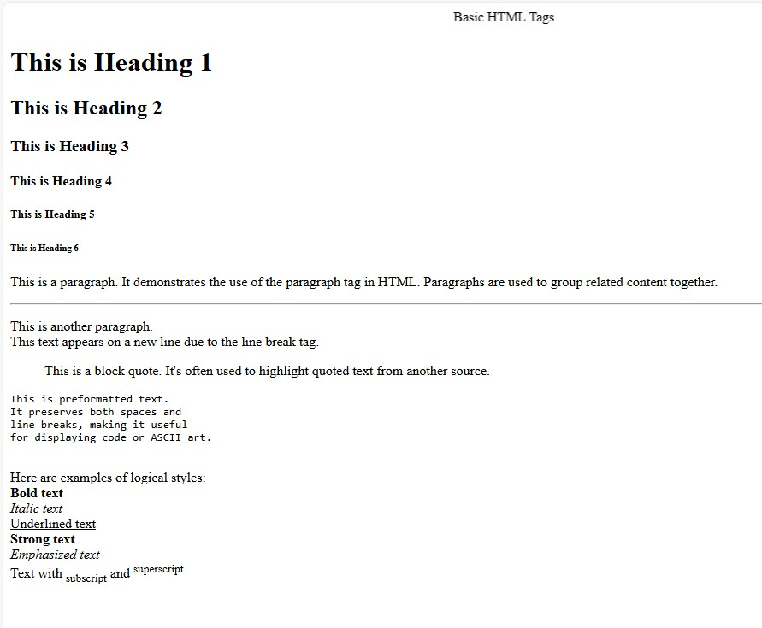
OutPut:-

Develop the HTML page named as “Table.html” to display your class time table. a) Provide the title as Time Table with table header and table footer, row-span and col- span etc. b) Provide various colour options to the cells (Highlight the lab hours and elective hours with different colours.) c) Provide colour options for rows.
<!DOCTYPE html>
<html lang="en">
<head>
<meta charset="UTF-8">
<meta name="viewport" content="width=device-width, initial-scale=1.0">
<title>Time Table</title>
<style> body {
font-family: Arial, sans-serif; line-height: 1.6;
margin: 0;
padding: 20px;
}
table {
width: 100%;
border-collapse: collapse;
}
th, td {
border: 1px solid #ddd; padding: 8px;
text-align: center;
}
th {
background-color: #f2f2f2;

}
.lab-hours {
background-color: #ffcccb;
}
.elective-hours {
background-color: #90ee90;
}
.lunch {
background-color: #ffd700;
}
.odd-row {
background-color: #f8f8f8;
}
tfoot {
background-color: #e6e6e6; font-weight: bold;
}
</style>
</head>
<body>
<table>
<thead>
<tr>
<th colspan="7">Class Time Table</th>
</tr>
<tr>
<th>Time</th>

<th>Monday</th>
<th>Tuesday</th>
<th>Wednesday</th>
<th>Thursday</th>
<th>Friday</th>
<th>Saturday</th>
</tr>
</thead>
<tbody>
<tr>
<td>9:00 - 10:00</td>
<td>Math</td>
<td>English</td>
<td>Science</td>
<td>History</td>
<td>Geography</td>
<td rowspan="6">No Classes</td>
</tr>
<tr class="odd-row">
<td>10:00 - 11:00</td>
<td>Physics</td>
<td>Chemistry</td>
<td>Biology</td>
<td class="elective-hours">Computer Science</td>
<td class="elective-hours">Art</td>
</tr>
<tr>

<td>11:00 - 12:00</td>
<td class="lab-hours" colspan="2">Physics Lab</td>
<td class="lab-hours" colspan="2">Chemistry Lab</td>
<td class="lab-hours">Biology Lab</td>
</tr>
<tr class="odd-row">
<td>12:00 - 13:00</td>
<td class="lunch" colspan="5">Lunch Break</td>
</tr>
<tr>
<td>13:00 - 14:00</td>
<td>Literature</td>
<td>Math</td>
<td>English</td>
<td>Physics</td>
<td>Chemistry</td>
</tr>
<tr class="odd-row">
<td>14:00 - 15:00</td>
<td class="elective-hours">Music</td>
<td class="elective-hours">Drama</td>
<td class="lab-hours" colspan="3">Computer Lab</td>
</tr>
</tbody>
<tfoot>
<tr>
<td colspan="7">* Lab hours are highlighted in pink, elective hours in light green</td>

</tr>
</tfoot>
</table>
</body>
</html>
OutPut:-

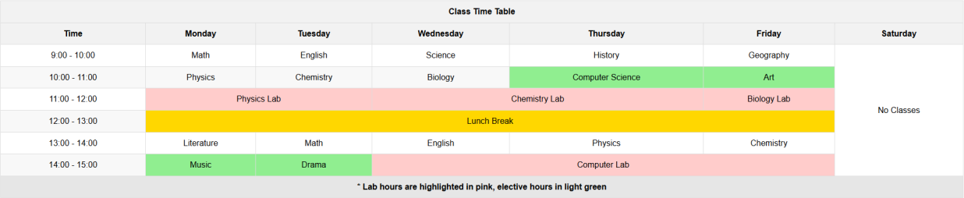

Develop an external style sheet named as “style.css” and provide different styles for h2, h3, hr, p, div, span, time, img & a tags. Apply different CSS selectors for tags and demonstrate the significance of each.
<!DOCTYPE html>
<html lang="en">
<head>
<meta charset="UTF-8">
<meta name="viewport" content="width=device-width, initial-scale=1.0">
<title>Sample Styled Page (No Div)</title>
<script>
/* Element Selector */ h2 {
color: #2c3e50;
font-family: 'Arial', sans-serif; border-bottom: 2px solid #3498db; padding-bottom: 10px;
}

/* Element Selector with Pseudo-class */ h3:hover {
color: #e74c3c; cursor: pointer;
transition: color 0.3s ease;
}

/* Element Selector */ hr {
border: 0; height: 1px;

background-image: linear-gradient(to right, rgba(0, 0, 0, 0), rgba(0, 0, 0, 0.75), rgba(0, 0, 0,
0));
}

/* Element Selector with Attribute */ p[lang] {
font-style: italic;
}

/* Class Selector */
.highlight {
background-color: #f1c40f; padding: 5px;
}

/* ID Selector */ #main-content {
max-width: 800px; margin: 0 auto; padding: 20px;
background-color: #ecf0f1;
}

/* Descendant Selector */ div p {
line-height: 1.6; margin-bottom: 15px;
}

/* Child Selector */ div > span {
font-weight: bold; color: #16a085;
}

/* Adjacent Sibling Selector */ h2 + p {
font-size: 1.1em; color: #7f8c8d;
}

/* Attribute Selector */ time[datetime] {
color: #8e44ad; font-weight: bold;
}

/* Pseudo-element Selector */ p::first-letter {
font-size: 1.5em; font-weight: bold; color: #c0392b;
}

/* Multiple Selectors */ img, a {
border: 1px solid #bdc3c7;

padding: 5px;
}

/* Pseudo-class Selector for Links */ a:link, a:visited {
color: #3498db;
text-decoration: none;
}

a:hover, a:active { color: #e74c3c;
text-decoration: underline;
}

/* Attribute Selector for Images */ img[alt] {
max-width: 100%; height: auto;
}

/* Combining Selectors */ div.special p {
text-indent: 20px; color: #27ae60;
}
</script>
</head>
<body>

<main id="main-content">
<h2>Welcome to Our Styled Page</h2>
<p>This is a paragraph right after an h2. It demonstrates the adjacent sibling selector.</p>

<h3>Hover over me!</h3>

<hr>

<p lang="en">This paragraph has a lang attribute, demonstrating the attribute selector.</p>

<p>Here's a <span class="highlight">highlighted</span> word using the class selector.</p>

<section>
<p>This paragraph is inside a section, showing the descendant selector.</p>
<span>This span is a direct child of the section.</span>
</section>

<p>The current date and time: <time datetime="2023-08-31">August 31, 2023</time></p>

<p>Notice how the first letter of each paragraph is styled differently.</p>

<article class="special">
<p>This paragraph is inside an article with class="special".</p>
</article>

<img src="https://d3njjcbhbojbot.cloudfront.net/api/utilities/v1/imageproxy/https://images.ctfassets
.net/wp1lcwdav1p1/6z473u5f7WaFUnr9GxDEk2/085274c4a841bd2dc900ebca36c43c9c/Get tyImages- 1255905237.jpg?w=1500&h=680&q=60&fit=fill&f=faces&fm=jpg&fl=progressive&auto=f ormat%2Ccompress&dpr=1&w=1000" alt="A placeholder image">

<p>Check out this <a href="https://searchcreators.org/">link</a> to see different link states.</p>
</main>
</body>
</html>
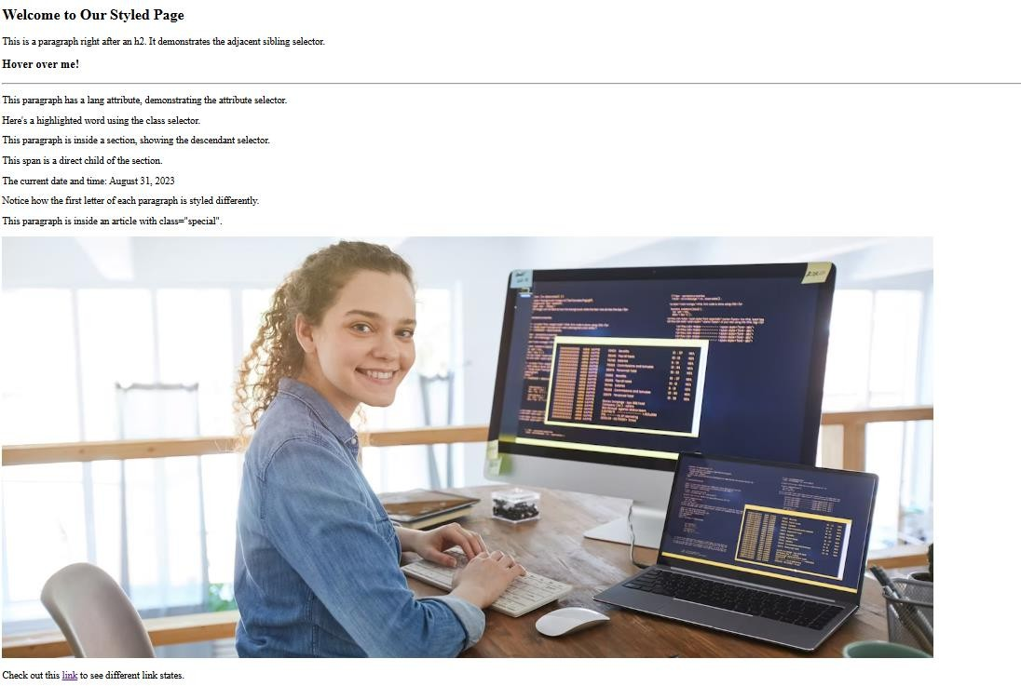
OutPut:-

Develop HTML page named as “registration.html” having variety of HTML input elements with background colors, table for alignment & provide font colors & size using CSS styles.
<!DOCTYPE html>
<html lang="en">
<head>
<meta charset="UTF-8">
<meta name="viewport" content="width=device-width, initial-scale=1.0">
<title>Registration Form</title>
<style>
body {
font-family: Arial, sans-serif; background-color: #f0f0f0; margin: 0;
padding: 20px;
}
h1 {
color: #333;
text-align: center;
}
table {
width: 100%;
max-width: 600px; margin: 0 auto; background-color: #fff; padding: 20px;
border-radius: 8px;
box-shadow: 0 0 10px rgba(0,0,0,0.1);
}

td {
padding: 10px;
}
label {
color: #555;
font-weight: bold;
}
input[type="text"], input[type="email"], input[type="password"], select, textarea { width: 100%;
padding: 8px;
border: 1px solid #ddd; border-radius: 4px;
box-sizing: border-box; font-size: 16px;
}
input[type="radio"], input[type="checkbox"] { margin-right: 5px;
}
input[type="submit"] { background-color: #4CAF50; color: white;
padding: 10px 20px; border: none;
border-radius: 4px; cursor: pointer; font-size: 18px;
}
input[type="submit"]:hover {

background-color: #45a049;
}
.error {
color: #ff0000; font-size: 14px;
}
</style>
</head>
<body>
<h1>Registration Form</h1>
<form action="#" method="post">
<table>
<tr>
<td><label for="fullname">Full Name:</label></td>
<td><input type="text" id="fullname" name="fullname" required></td>
</tr>
<tr>
<td><label for="email">Email:</label></td>
<td><input type="email" id="email" name="email" required></td>
</tr>
<tr>
<td><label for="password">Password:</label></td>
<td><input type="password" id="password" name="password" required></td>
</tr>
<tr>
<td><label for="confirm_password">Confirm Password:</label></td>
<td><input type="password" id="confirm_password" name="confirm_password" required></td>
</tr>

<tr>
<td><label>Gender:</label></td>
<td>
<input type="radio" id="male" name="gender" value="male" required>
<label for="male">Male</label>
<input type="radio" id="female" name="gender" value="female" required>
<label for="female">Female</label>
<input type="radio" id="other" name="gender" value="other" required>
<label for="other">Other</label>
</td>
</tr>
<tr>
<td><label for="birthdate">Date of Birth:</label></td>
<td><input type="date" id="birthdate" name="birthdate" required></td>
</tr>
<tr>
<td><label for="country">Country:</label></td>
<td>
<select id="country" name="country" required>
<option value="">Select a country</option>
<option value="usa">India</option>
<option value="uk">United Kingdom</option>
<option value="canada">Canada</option>
<option value="australia">Australia</option>
<option value="other">Other</option>
</select>
</td>
</tr>

<tr>
<td><label for="interests">Interests:</label></td>
<td>
<input type="checkbox" id="sports" name="interests[]" value="sports">
<label for="sports">Sports</label>
<input type="checkbox" id="music" name="interests[]" value="music">
<label for="music">Music</label>
<input type="checkbox" id="reading" name="interests[]" value="reading">
<label for="reading">Reading</label>
<input type="checkbox" id="travel" name="interests[]" value="travel">
<label for="travel">Travel</label>
</td>
</tr>
<tr>
<td><label for="bio">Bio:</label></td>
<td><textarea id="bio" name="bio" rows="4"></textarea></td>
</tr>
<tr>
<td colspan="2" style="text-align: center;">
<input type="submit" value="Register">
</td>
</tr>
</table>
</form>
</body>
</html>

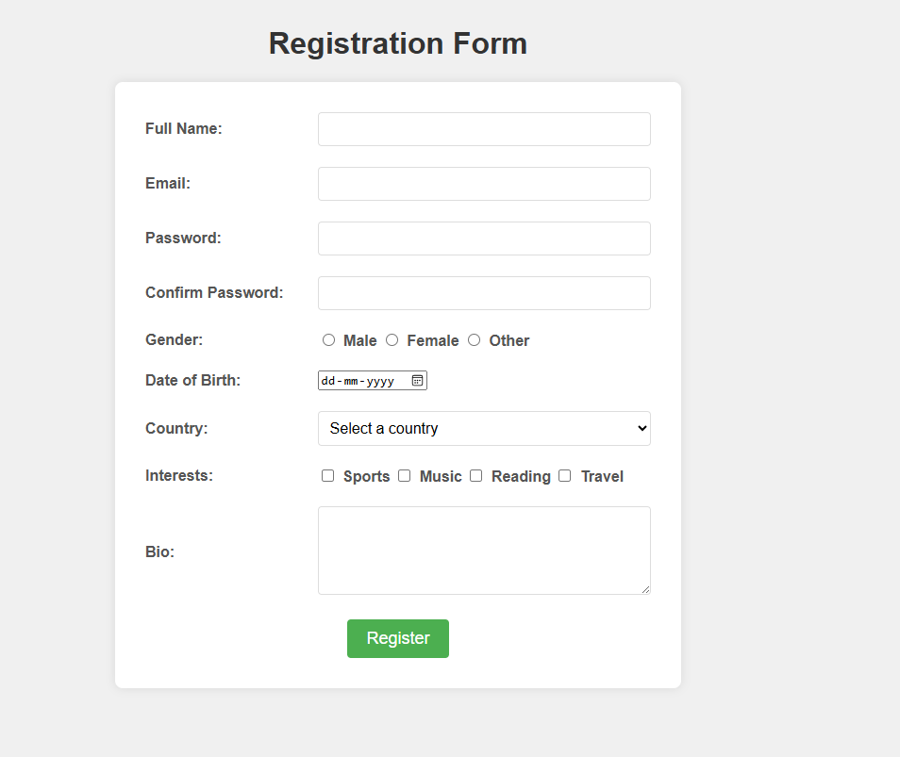
OutPut:-

Develop HTML page named as “newpaper.html” having variety of HTML semantic elements with background colors, text-colors & size for figure, table, aside, section, article, header, footer… etc.
<!DOCTYPE html>
<html lang="en">
<head>
<meta charset="UTF-8">
<meta name="viewport" content="width=device-width, initial-scale=1.0">
<title>The Daily Chronicle</title>
<style>
body {
font-family: 'Georgia', serif; line-height: 1.6;
color: #333;
max-width: 1200px; margin: 0 auto; padding: 20px;
background-color: #f4f4f4;
}
header {
background-color: #1a1a1a; color: #fff;
padding: 20px; text-align: center;
}
header h1 { margin: 0;
font-size: 2.5em;
}

nav {
background-color: #333; color: #fff;
padding: 10px;
}
nav ul {
list-style-type: none; padding: 0;
margin: 0; display: flex;
justify-content: center;
}
nav ul li {
margin: 0 10px;
}
nav ul li a { color: #fff;
text-decoration: none;
}
main {
display: flex; margin-top: 20px;
}
section { flex: 2;
margin-right: 20px;
}
article {

background-color: #fff; padding: 20px;
margin-bottom: 20px;
box-shadow: 0 0 10px rgba(0,0,0,0.1);
}
article h2 {
color: #1a1a1a; font-size: 1.8em;
}
aside {
flex: 1;
background-color: #e6e6e6; padding: 20px;
box-shadow: 0 0 10px rgba(0,0,0,0.1);
}
figure {
margin: 0;
text-align: center;
}
figure img {
max-width: 100%; height: auto;
}
figcaption {
font-style: italic; color: #666;
font-size: 0.9em;
}

table {
width: 100%;
border-collapse: collapse; margin-bottom: 20px;
}
th, td {
border: 1px solid #ddd; padding: 10px;
text-align: left;
}
th {
background-color: #f2f2f2;
}
footer {
background-color: #1a1a1a; color: #fff;
text-align: center; padding: 10px; margin-top: 20px;
}
</style>
</head>
<body>
<header>
<h1>The Daily Chronicle</h1>
</header>

<nav>

<ul>
<li><a href="#">Home</a></li>
<li><a href="#">Politics</a></li>
<li><a href="#">Technology</a></li>
<li><a href="#">Sports</a></li>
<li><a href="#">Entertainment</a></li>
</ul>
</nav>

<main>
<section>
<article>
<h2>Breaking News: Major Technological Breakthrough</h2>
<p>Scientists have announced a groundbreaking discovery in the field of quantum computing, potentially revolutionizing the tech industry.</p>
<figure>
<img src="https://www.cnet.com/a/img/resize/c7cb26e927bebaa784fb55a01e71d7fecb15d2e3/hub/ 2019/06/26/3f76e99d-8055-46f3-8f27-558ee276b665/20180405-ibm-q-quantum-computer- 02.jpg?auto=webp&fit=crop&height=675&width=1200" alt="Quantum Computer">
<figcaption>A state-of-the-art quantum computer at the research facility</figcaption>
</figure>
</article>

<article>
<h2>Local Sports Team Wins Championship</h2>
<p>In a thrilling match, our local team secured victory in the national championship, bringing pride to our city.</p>
<table>

<tr>
<th>Team</th>
<th>Score</th>
</tr>
<tr>
<td>Local Heroes</td>
<td>3</td>
</tr>
<tr>
<td>Visiting Challengers</td>
<td>2</td>
</tr>
</table>
</article>
</section>

<aside>
<h3>Weather Update</h3>
<p>Expect sunny skies with a high of 75°F (24°C) today.</p>

<h3>Upcoming Events</h3>
<ul>
<li>City Festival - This Weekend</li>
<li>Tech Conference - Next Month</li>
<li>Charity Run - In Two Weeks</li>
</ul>
</aside>
</main>

<footer>
<p>&copy; 2023 The Daily Chronicle. All rights reserved.</p>
</footer>
</body>
</html>

OutPut:-

Apply HTML, CSS and JavaScript to design a simple calculator to perform the following operations: sum, product, difference, remainder, quotient, power, square-root and square.
<!DOCTYPE html>
<html lang="en">
<head>
<meta charset="UTF-8">
<meta name="viewport" content="width=device-width, initial-scale=1.0">
<title>Simple Calculator</title>
<style>
body {
font-family: Arial, sans-serif; display: flex;
justify-content: center; align-items: center; height: 100vh; margin: 0;
background-color: #f0f0f0;
}
.calculator {
background-color: #fff; border-radius: 8px;
box-shadow: 0 0 10px rgba(0,0,0,0.1); padding: 20px;
width: 300px;
}
#display { width: 100%; height: 40px;

font-size: 1.5em; text-align: right;
margin-bottom: 10px; padding: 5px;
box-sizing: border-box;
}
.buttons { display: grid;
grid-template-columns: repeat(4, 1fr); gap: 10px;
}
button {
padding: 10px; font-size: 1.2em; border: none;
background-color: #e0e0e0; cursor: pointer;
border-radius: 4px;
}
button:hover {
background-color: #d0d0d0;
}
.operator {
background-color: #f0a030; color: white;
}
.operator:hover {
background-color: #e09020;

}
</style>
</head>
<body>
<div class="calculator">
<input type="text" id="display" readonly>
<div class="buttons">
<button onclick="appendToDisplay('7')">7</button>
<button onclick="appendToDisplay('8')">8</button>
<button onclick="appendToDisplay('9')">9</button>
<button class="operator" onclick="setOperation('+')">&plus;</button>
<button onclick="appendToDisplay('4')">4</button>
<button onclick="appendToDisplay('5')">5</button>
<button onclick="appendToDisplay('6')">6</button>
<button class="operator" onclick="setOperation('-')">&minus;</button>
<button onclick="appendToDisplay('1')">1</button>
<button onclick="appendToDisplay('2')">2</button>
<button onclick="appendToDisplay('3')">3</button>
<button class="operator" onclick="setOperation('*')">&times;</button>
<button onclick="appendToDisplay('0')">0</button>
<button onclick="appendToDisplay('.')">.</button>
<button class="operator" onclick="calculate()">&equals;</button>
<button class="operator" onclick="setOperation('/')">&divide;</button>
<button class="operator" onclick="setOperation('%')">%</button>
<button class="operator" onclick="setOperation('^')">x<sup>y</sup></button>
<button class="operator" onclick="squareRoot()">√</button>
<button class="operator" onclick="square()">x<sup>2</sup></button>
<button onclick="clearDisplay()">C</button>

</div>
</div>

<script>
let display = document.getElementById('display'); let currentValue = '';
let operation = '';
let previousValue = '';

function appendToDisplay(value) { currentValue += value; display.value = currentValue;
}

function clearDisplay() { currentValue = ''; operation = ''; previousValue = ''; display.value = '';
}

function setOperation(op) { if (currentValue !== '') {
if (previousValue !== '') { calculate();
}
operation = op;
previousValue = currentValue;

currentValue = '';
}
}

function calculate() {
if (previousValue !== '' && currentValue !== '') { let result;
const prev = parseFloat(previousValue); const current = parseFloat(currentValue); switch(operation) {
case '+':
result = prev + current; break;
case '-':
result = prev - current; break;
case '*':
result = prev * current; break;
case '/':
result = prev / current; break;
case '%':
result = prev % current; break;
case '^':
result = Math.pow(prev, current); break;

}
display.value = result; previousValue = result.toString(); currentValue = '';
operation = '';
}
}

function squareRoot() {
if (currentValue !== '') {
const result = Math.sqrt(parseFloat(currentValue)); display.value = result;
currentValue = result.toString();
}
}

function square() {
if (currentValue !== '') {
const result = Math.pow(parseFloat(currentValue), 2); display.value = result;
currentValue = result.toString();
}
}
</script>
</body>
</html>

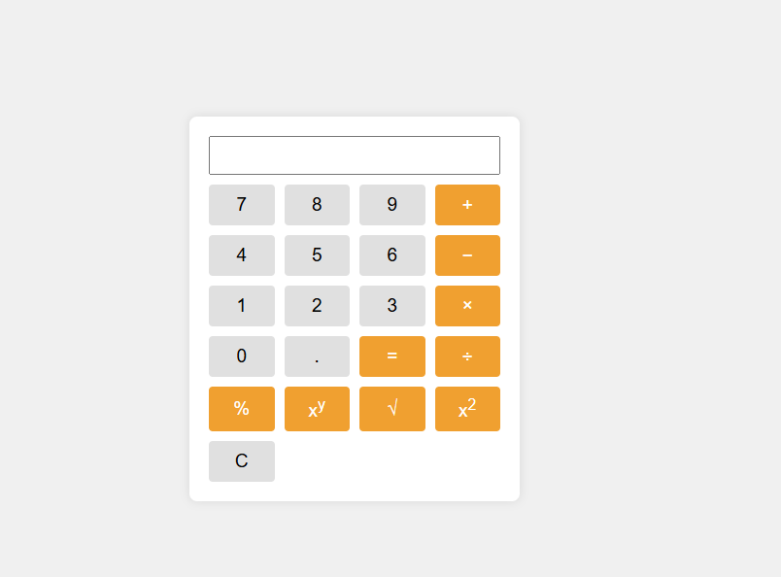
OutPut:-

Develop JavaScript program (with HTML/CSS) for: a) Converting JSON text to JavaScript Object b) Convert JSON results into a date c) Converting From JSON To CSV and CSV to JSON d) Create hash from string using crypto.createHash() method.
<!DOCTYPE html>
<html lang="en">
<head>
<meta charset="UTF-8">
<meta name="viewport" content="width=device-width, initial-scale=1.0">
<title>JSON/CSV Converter and Hash Generator</title>
<script src="https://cdnjs.cloudflare.com/ajax/libs/crypto-js/4.1.1/crypto- js.min.js"></script>
<style>
body {
font-family: Arial, sans-serif; line-height: 1.6;
margin: 0; padding: 20px;
background-color: #f4f4f4;
}
.container {
max-width: 800px; margin: auto; background: white; padding: 20px; border-radius: 5px;
box-shadow: 0 0 10px rgba(0,0,0,0.1);
}
h1 {
color: #333;

}
textarea { width: 100%;
height: 100px; margin-bottom: 10px;
}
button {
background-color: #4CAF50; color: white;
padding: 10px 15px; border: none;
border-radius: 4px; cursor: pointer; margin-right: 10px;
}
button:hover {
background-color: #45a049;
}
#result {
margin-top: 20px; padding: 10px;
background-color: #e7e7e7; border-radius: 4px;
}
</style>
</head>
<body>
<div class="container">

<h1>JSON/CSV Converter and Hash Generator</h1>

<h2>a) Convert JSON to JavaScript Object</h2>
<textarea id="jsonInput" placeholder="Enter JSON here"></textarea>
<button onclick="convertJsonToObject()">Convert to Object</button>

<h2>b) Convert JSON to Date</h2>
<textarea id="jsonDateInput" placeholder='Enter JSON date string (e.g., {"date": "2023- 05-15T12:00:00Z"})'></textarea>
<button onclick="convertJsonToDate()">Convert to Date</button>

<h2>c) Convert JSON to CSV and CSV to JSON</h2>
<textarea id="dataInput" placeholder="Enter JSON or CSV here"></textarea>
<button onclick="convertJsonToCsv()">JSON to CSV</button>
<button onclick="convertCsvToJson()">CSV to JSON</button>

<h2>d) Create Hash from String</h2>
<textarea id="hashInput" placeholder="Enter string to hash"></textarea>
<button onclick="createHash()">Generate Hash</button>

<div id="result"></div>
</div>

<script>
function convertJsonToObject() { try {
const jsonInput = document.getElementById('jsonInput').value; const jsObject = JSON.parse(jsonInput);

document.getElementById('result').innerText = 'Converted Object: ' + JSON.stringify(jsObject, null, 2);
} catch (error) {
document.getElementById('result').innerText = 'Error: ' + error.message;
}
}

function convertJsonToDate() { try {
const jsonInput = document.getElementById('jsonDateInput').value; const jsObject = JSON.parse(jsonInput);
const date = new Date(jsObject.date);
document.getElementById('result').innerText = 'Converted Date: ' + date.toString();
} catch (error) {
document.getElementById('result').innerText = 'Error: ' + error.message;
}
}

function convertJsonToCsv() { try {
const jsonInput = document.getElementById('dataInput').value; const jsObject = JSON.parse(jsonInput);
const headers = Object.keys(jsObject[0]); const csvRows = [
headers.join(','),
...jsObject.map(row => headers.map(fieldName => JSON.stringify(row[fieldName])).join(','))
];
const csvString = csvRows.join('\n');

document.getElementById('result').innerText = 'Converted CSV:\n' + csvString;
} catch (error) {
document.getElementById('result').innerText = 'Error: ' + error.message;
}
}

function convertCsvToJson() { try {
const csvInput = document.getElementById('dataInput').value; const lines = csvInput.split('\n');
const headers = lines[0].split(',');
const jsonArray = lines.slice(1).map(line => { const values = line.split(',');
return headers.reduce((obj, header, index) => { obj[header] = values[index];
return obj;
}, {});
});
document.getElementById('result').innerText = 'Converted JSON:\n' + JSON.stringify(jsonArray, null, 2);
} catch (error) {
document.getElementById('result').innerText = 'Error: ' + error.message;
}
}

function createHash() { try {
const input = document.getElementById('hashInput').value; const hash = CryptoJS.SHA256(input);

hash;
document.getElementById('result').innerText = 'Generated Hash (SHA-256): ' +

} catch (error) {
document.getElementById('result').innerText = 'Error: ' + error.message;

}
}
</script>
</body>
</html>
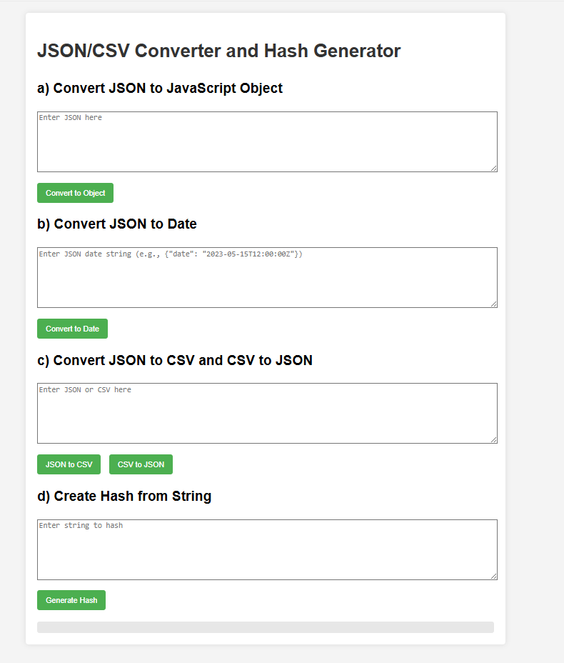
OutPut:-

a. Develop a PHP program (with HTML/CSS) to keep track of the number of visitors visiting the web page and to display this count of visitors, with relevant headings. b. Develop a PHP program (with HTML/CSS) to sort the student records which are stored in the database using selection sort.
a. Develop a PHP program (with HTML/CSS) to keep track of the number of visitors visiting the web page and to display this count of visitors, with relevant headings
<!DOCTYPE html>
<html lang="en">
<head>
<meta charset="UTF-8">
<meta name="viewport" content="width=device-width, initial-scale=1.0">
<title>Visitor Counter</title>
<style>
body {
font-family: Arial, sans-serif; line-height: 1.6;
margin: 0; padding: 20px;
background-color: #f4f4f4;
}
.container {
max-width: 600px; margin: auto; background: white; padding: 20px; border-radius: 5px;
box-shadow: 0 0 10px rgba(0,0,0,0.1);
}
h1 {
color: #333;

text-align: center;
}
.counter {
font-size: 24px; text-align: center; margin-top: 20px;
}
</style>
</head>
<body>
<div class="container">
<h1>Welcome to Our Website</h1>
<div class="counter">
<?php
$counterFile = 'visitor_count.txt';

// Read the current count
if (file_exists($counterFile)) {
$count = (int)file_get_contents($counterFile);
} else {
$count = 0;
}

// Increment the count
$count++;

// Save the new count file_put_contents($counterFile, $count);

// Display the count
echo "<h2>Visitor Count</h2>";
echo "<p>You are visitor number: $count</p>";
?>
</div>
</div>
</body>
</html>

b) Develop a PHP program (with HTML/CSS) to sort the student records which are stored in the database using selection sort.
<!DOCTYPE html>
<html lang="en">
<head>
<meta charset="UTF-8">
<meta name="viewport" content="width=device-width, initial-scale=1.0">
<title>Student Record Sorter</title>
<style>
body {
font-family: Arial, sans-serif; line-height: 1.6;
margin: 0; padding: 20px;
background-color: #f4f4f4;
}
.container {
max-width: 800px; margin: auto; background: white;

padding: 20px; border-radius: 5px;
box-shadow: 0 0 10px rgba(0,0,0,0.1);
}
h1 {
color: #333;
text-align: center;
}
table {
width: 100%;
border-collapse: collapse; margin-top: 20px;
}
th, td {
padding: 10px;
border: 1px solid #ddd; text-align: left;
}
th {
background-color: #f2f2f2;
}
</style>
</head>
<body>
<div class="container">
<h1>Student Records</h1>
<?php
// Database connection details

$host = 'localhost';
$dbname = 'student_records';
$username = 'your_username';
$password = 'your_password';

try {
$pdo = new PDO("mysql:host=$host;dbname=$dbname", $username, $password);
$pdo->setAttribute(PDO::ATTR_ERRMODE, PDO::ERRMODE_EXCEPTION);

// Fetch student records
$stmt = $pdo->query("SELECT * FROM students");
$students = $stmt->fetchAll(PDO::FETCH_ASSOC);

// Selection sort function
function selectionSort(&$arr, $n) { for ($i = 0; $i < $n - 1; $i++) {
$min_idx = $i;
for ($j = $i + 1; $j < $n; $j++) {
if ($arr[$j]['gpa'] < $arr[$min_idx]['gpa']) {
$min_idx = $j;
}
}
if ($min_idx != $i) {
$temp = $arr[$i];
$arr[$i] = $arr[$min_idx];
$arr[$min_idx] = $temp;
}
}

}

// Sort students by GPA selectionSort($students, count($students));

// Display sorted student records echo "<table>";
echo "<tr><th>ID</th><th>Name</th><th>GPA</th></tr>"; foreach ($students as $student) {
echo "<tr>";
echo "<td>" . htmlspecialchars($student['id']) . "</td>"; echo "<td>" . htmlspecialchars($student['name']) . "</td>"; echo "<td>" . htmlspecialchars($student['gpa']) . "</td>"; echo "</tr>";
}
echo "</table>";

} catch(PDOException $e) {
echo "Connection failed: " . $e->getMessage();
}
?>
</div>
</body>
</html>

OUTPUT:

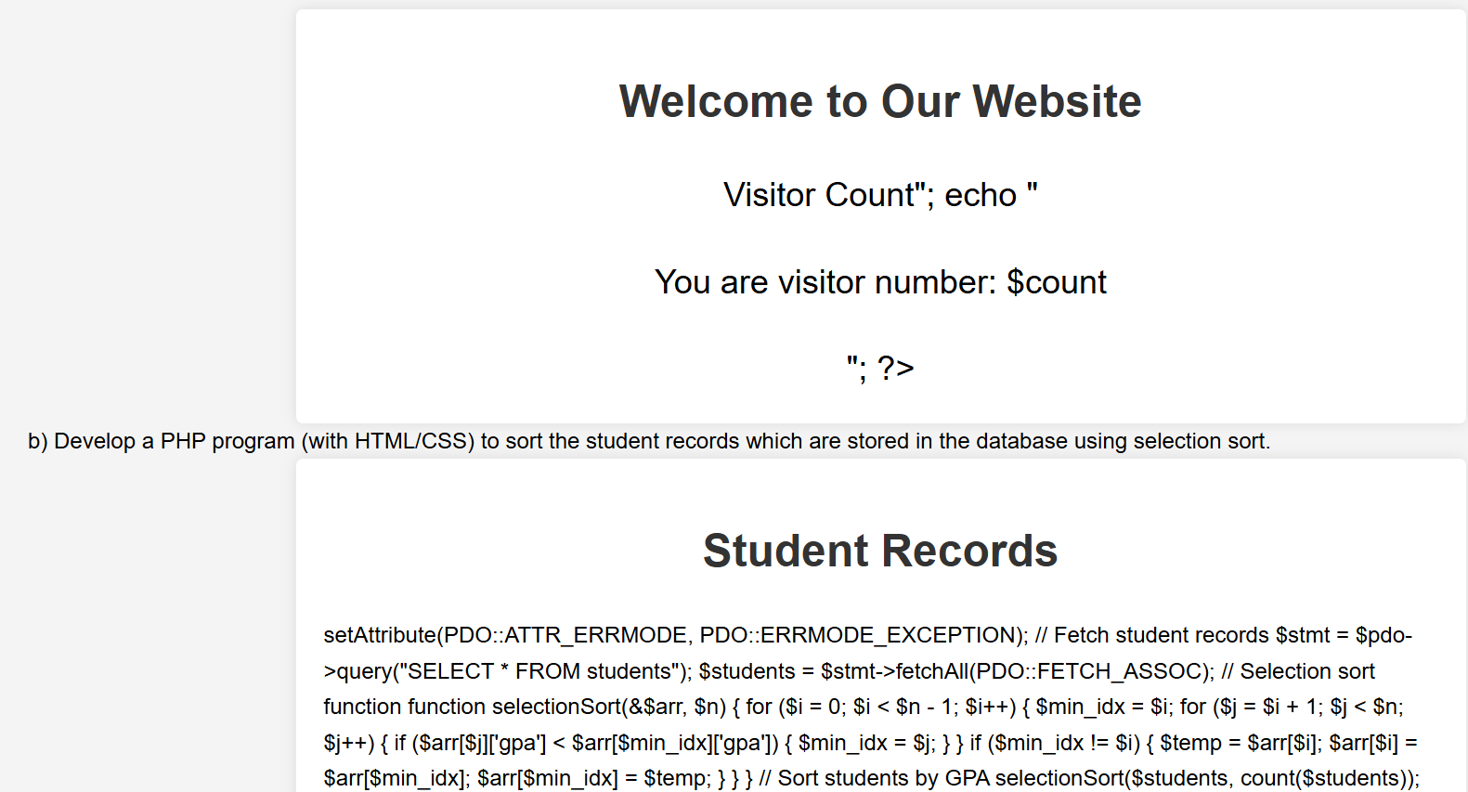

Develop jQuery script (with HTML/CSS) for: a. Appends the content at the end of the existing paragraph and list. b. Change the state of the element with CSS style using animate() method c. Change the color of any div that is animated.
<!DOCTYPE html>
<html lang="en">
<head>
<meta charset="UTF-8">
<meta name="viewport" content="width=device-width, initial-scale=1.0">
<title>jQuery Append, Animate, and Color Change Demo</title>
<script src="https://code.jquery.com/jquery-3.6.0.min.js"></script>
<style>
body {
font-family: Arial, sans-serif; line-height: 1.6;
margin: 0; padding: 20px;
background-color: #f4f4f4;
}
.container {
max-width: 800px; margin: auto; background: white; padding: 20px; border-radius: 5px;
box-shadow: 0 0 10px rgba(0,0,0,0.1);
}
h1, h2 {
color: #333;
}

.box {
width: 100px; height: 100px;
background-color: #3498db; margin: 20px 0;
}
button {
padding: 10px 15px; background-color: #2ecc71; color: white;
border: none; border-radius: 5px; cursor: pointer; margin-right: 10px;
}
button:hover {
background-color: #27ae60;
}
</style>
</head>
<body>
<div class="container">
<h1>jQuery Demonstration</h1>

<h2>a. Append Content</h2>
<p id="existingParagraph">This is an existing paragraph. </p>
<ul id="existingList">
<li>Existing item 1</li>

<li>Existing item 2</li>
</ul>
<button id="appendButton">Append Content</button>

<h2>b. Animate Element</h2>
<div id="animateBox" class="box"></div>
<button id="animateButton">Animate Box</button>

<h2>c. Change Color of Animated Div</h2>
<div id="colorBox" class="box"></div>
<button id="colorAnimateButton">Animate and Change Color</button>
</div>

<script>
$(document).ready(function() {
// a. Append content
$("#appendButton").click(function() {
$("#existingParagraph").append("This content is appended.");
$("#existingList").append("<li>Appended item</li>");
});

// b. Animate element
$("#animateButton").click(function() {
$("#animateBox").animate({ width: "200px",
height: "200px", opacity: 0.5
}, 1000);

});

// c. Animate and change color
$("#colorAnimateButton").click(function() {
$("#colorBox").animate({ width: "200px",
height: "200px"
}, {
duration: 1000,
step: function(now, fx) {
if (fx.prop === "width") {
$(this).css("background-color", `rgb(${Math.round(now)}, 52, 219)`);
}
}
});
});
});
</script>
</body>
</html>

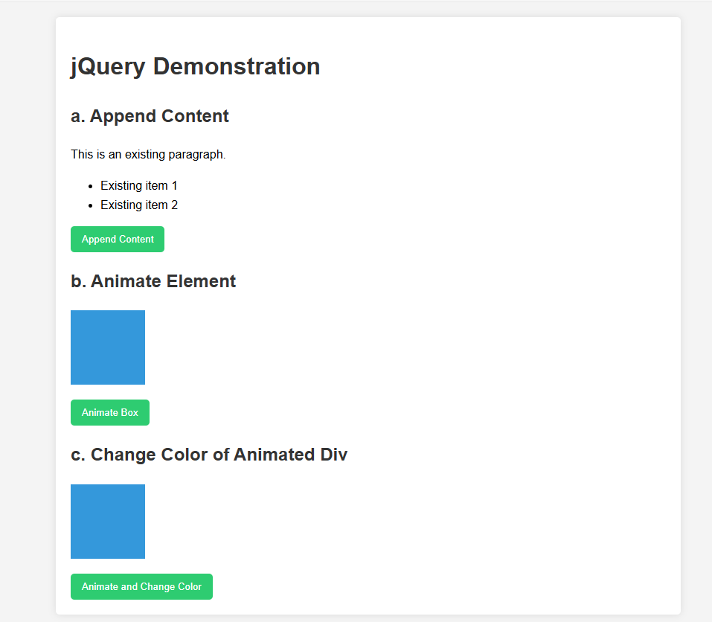
OutPut:-

Develop a JavaScript program with Ajax (with HTML/CSS) for: a. Use ajax() method (without Jquery) to add the text content from the text file by sending ajax request. b. Use ajax() method (with Jquery) to add the text content from the text file by sending ajax request. c. Illustrate the use of getJSON() method in jQuery d. Illustrate the use of parseJSON() method to display JSON values.
<!DOCTYPE html>
<html lang="en">
<head>
<meta charset="UTF-8">
<meta name="viewport" content="width=device-width, initial-scale=1.0">
<title>Ajax Demo Program</title>
<script src="https://cdnjs.cloudflare.com/ajax/libs/jquery/3.6.0/jquery.min.js"></script>
<style>
body {
font-family: Arial, sans-serif; line-height: 1.6;
margin: 0; padding: 20px;
background-color: #f4f4f4;
}
.container {
max-width: 800px; margin: auto; background: white; padding: 20px; border-radius: 5px;
box-shadow: 0 0 10px rgba(0,0,0,0.1);
}
h1 {
color: #333;

}
h2 {
color: #666;
}
button {
background-color: #4CAF50; border: none;
color: white; padding: 10px 20px; text-align: center; text-decoration: none; display: inline-block; font-size: 16px; margin: 4px 2px; cursor: pointer; border-radius: 4px;
}
pre {
background-color: #f8f8f8; border: 1px solid #ddd; border-radius: 4px; padding: 10px;
white-space: pre-wrap; word-wrap: break-word;
}
</style>
</head>
<body>

<div class="container">
<h1>Ajax Demo Program</h1>

<h2>a. Ajax-like operation without jQuery</h2>
<button onclick="operationWithoutJQuery()">Perform Operation (without jQuery)</button>
<pre id="result-a"></pre>

<h2>b. Ajax-like operation with jQuery</h2>
<button onclick="operationWithJQuery()">Perform Operation (with jQuery)</button>
<pre id="result-b"></pre>

<h2>c. jQuery-like getJSON() method</h2>
<button onclick="getJSONOperation()">Get JSON</button>
<pre id="result-c"></pre>

<h2>d. jQuery parseJSON() method</h2>
<button onclick="parseJSONExample()">Parse JSON</button>
<pre id="result-d"></pre>
</div>

<script>
// Simulated data
const simulatedData = {
text: "This is a sample text from a simulated server response.", json: {
name: "John Doe", age: 30,
city: "New York"

}
};

// a. Ajax-like operation without jQuery function operationWithoutJQuery() {
setTimeout(function() {
document.getElementById("result-a").textContent = simulatedData.text;
}, 500);
}

// b. Ajax-like operation with jQuery function operationWithJQuery() {
$.Deferred(function(deferred) { setTimeout(function() {
deferred.resolve(simulatedData.text);
}, 500);
}).done(function(result) {
$("#result-b").text(result);
});
}

// c. jQuery-like getJSON() method function getJSONOperation() {
$.Deferred(function(deferred) { setTimeout(function() {
deferred.resolve(simulatedData.json);
}, 500);
}).done(function(result) {

$("#result-c").text(JSON.stringify(result, null, 2));
});
}

// d. jQuery parseJSON() method function parseJSONExample() {
var jsonString = JSON.stringify(simulatedData.json); var jsonObject = $.parseJSON(jsonString);
$("#result-d").text(JSON.stringify(jsonObject, null, 2));
}
</script>
</body>
</html>
Output:
